ONEWAY PREC BY Temp
/STATISTICS DESCRIPTIVES HOMOGENEITY WELCH
/PLOT MEANS
/MISSING ANALYSIS.

Oneway

Notes
Output Created |  | 05-May-2019 23:54:41
Comments
Input | Active Dataset | DataSet0
Input | Filter | <none>
Input | Weight | <none>
Input | Split File | <none>
Input | N of Rows in Working Data File | 30
Missing Value Handling | Definition of Missing | User-defined missing values are treated as missing.
Missing Value Handling | Cases Used | Statistics for each analysis are based on cases with no missing data for any variable in the analysis.
Syntax |  | ONEWAY PREC BY Temp  /STATISTICS DESCRIPTIVES HOMOGENEITY WELCH  /PLOT MEANS  /MISSING ANALYSIS.
Resources | Processor Time | 00 00:00:00.156
Resources | Elapsed Time | 00 00:00:00.151

[DataSet0]

Descriptives
PREC
 | N | Mean | Std. Deviation | Std. Error
Between 22°C-18°C | 9 | 67.7778 | 30.52777 | 10.17592
Between 24°C-26°C | 6 | 35.0000 | 16.73320 | 6.83130
In between 24°C and 22°C | 13 | 26.5385 | 34.48337 | 9.56397
Less than 18°C | 2 | 85.0000 | 49.49747 | 35.00000
Total | 30 | 44.5000 | 36.42067 | 6.64947

Descriptives
PREC
 | 95% Confidence Interval for Mean |  | Minimum | Maximum
 | Lower Bound | Upper Bound | Minimum | Maximum
Between 22°C-18°C | 44.3121 | 91.2435 | 30.00 | 130.00
Between 24°C-26°C | 17.4396 | 52.5604 | 10.00 | 55.00
In between 24°C and 22°C | 5.7004 | 47.3766 | .00 | 125.00
Less than 18°C | -359.7172 | 529.7172 | 50.00 | 120.00
Total | 30.9003 | 58.0997 | .00 | 130.00

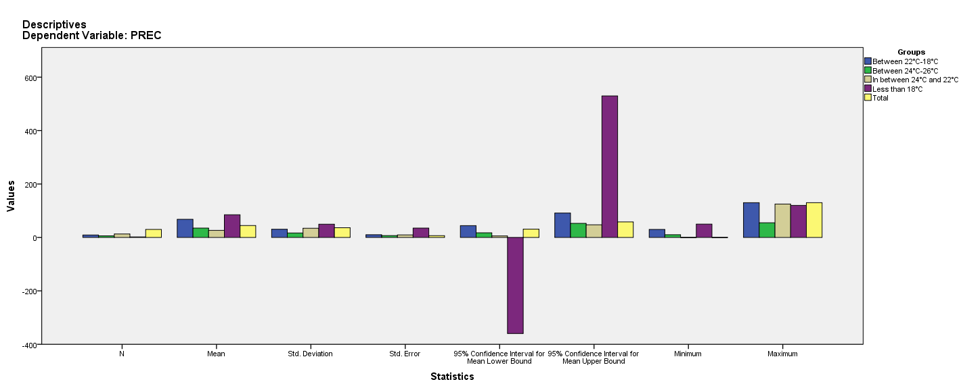

Test of Homogeneity of Variances
PREC
Levene Statistic | df1 | df2 | Sig.
.744 | 3 | 26 | .536

ANOVA
PREC
 | Sum of Squares | df | Mean Square | F | Sig.
Between Groups | 12892.714 | 3 | 4297.571 | 4.369 | .013
Within Groups | 25574.786 | 26 | 983.646
Total | 38467.500 | 29

Robust Tests of Equality of Means
PREC
 | Statisticª | df1 | df2 | Sig.
Welch | 2.959 | 3 | 4.411 | .150
a. Asymptotically F distributed.

Means Plots

